**You have to provide answer on this question paper. Answer on extra sheet will not be marked. You are allowed to take extra sheets for rough work. But that extra sheet will not be collected.**

**Problem 1: Arden’s Lemma [5 + 10 points]**

## Derive regular expression of the following DFA using Arden’s Lemma.

|  |
| --- |
| **Solution:**  **q0 = q0a + q1a + ˄ 🡪(1)**  **q1=q0b 🡪(2)**  **q2=q1b + q2(a+b)**  **put (2) in (1)**  **q0 = q0a + q0 ba + ˄**  **q0 = q0a + q0 ba + ˄**  **q0 = q0(a + ba) + ˄**  **Applying adren lemma**  **q0 = (a + ba)\*** |

## Convert following NFA-null to DFA

## 

|  |  |  |  |  |  |  |  |  |  |  |  |  |  |  |  |  |  |  |  |  |  |  |  |  |  |  |  |  |  |  |  |  |  |  |  |  |  |  |  |  |  |  |  |  |  |  |  |  |  |  |  |  |  |  |  |  |  |
| --- | --- | --- | --- | --- | --- | --- | --- | --- | --- | --- | --- | --- | --- | --- | --- | --- | --- | --- | --- | --- | --- | --- | --- | --- | --- | --- | --- | --- | --- | --- | --- | --- | --- | --- | --- | --- | --- | --- | --- | --- | --- | --- | --- | --- | --- | --- | --- | --- | --- | --- | --- | --- | --- | --- | --- | --- | --- |
| Solution: Given NFA – null table:   |  |  |  |  | | --- | --- | --- | --- | | state | null | a | b | | q0 | {q0,q1,q2} | {q0} | Φ | | q1(Final) | {q1} | {q1} | Φ | | q2(Final) | {q2} | Φ | {q3} | | q3 | {q3} | {q2} | Φ |  |  |  |  |  |  |  |  |  |  |  |  |  |  |  |  |  |  | | --- | --- | --- | --- | --- | --- | --- | --- | --- | --- | --- | --- | --- | --- | --- | --- | --- | | Covert to NFA   |  |  |  | | --- | --- | --- | | state | a | b | | q0 | {q0,q1} | {q3} | | q1(Final) | {q1} | Φ | | q2(Final) | Φ | {q3} | | q3 | {q2} | Φ | |  | | Convert to DFA   |  |  |  | | --- | --- | --- | | state | a | b | | q0 | {q0,q1} | q3 | | q2(Final) | trap | q3 | | q3 | q2 | trap | | {q0,q1}(Final) | {q0,q1} | q3 | | trap | trap | trap | |  | |

## Problem 2: Parser [10 + 5 points]

## Apply the CYK algorithm on the given CFG to determine whether this string ‘bbaba’ is accepted or not.

|  |  |  |  |  |  |  |  |  |  |  |  |  |  |  |  |  |  |
| --- | --- | --- | --- | --- | --- | --- | --- | --- | --- | --- | --- | --- | --- | --- | --- | --- | --- |
|  | |  |  |  |  |  |  |  |  |  |  |  |  |  |  |  |  | | --- | --- | --- | --- | --- | --- | --- | --- | --- | --- | --- | --- | --- | --- | --- | --- | | Solution:  |  | | --- | | S,C  bbaba | | -  bbab | -  baba | | -  bba | -  bab | B  aba | | A  bb | -  ba | S,C  ab | -  ba | | B,X  b | B,X  b | A,C  a | B,X  b | A,C  a | | |

## Prove whether the following grammar is ambiguous or not. If grammar is ambiguous then remove the ambiguity.

**S🡪 a S b | ab | T | ^**

**T🡪 aT | ^**

|  |
| --- |
| **Solution:**  S🡪aSb | T  T🡪 aT| ^ |

**Problem 3: CFL [5 + 10 points]**

1. Remove Null productions from the following grammar.

Tell whether the resulting grammar is CNF or not?

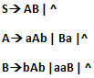

|  |
| --- |
| **Solution:**  **S🡪A|B|AB| ^**  **A🡪aAb|Ba|ab|a**  **B🡪bAb|aaB|bb|aa**  **Not in CNF** |

1. Develop PDA for the following language

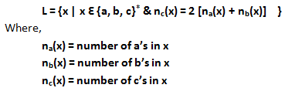

**Problem 4: Pumping Lemma [10 points]**

## Show that the following language is not context free using pumping lemma.

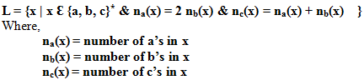

**Problem 5: Single Tape Turing Machine [15 points]**

You are given with a single tape TM.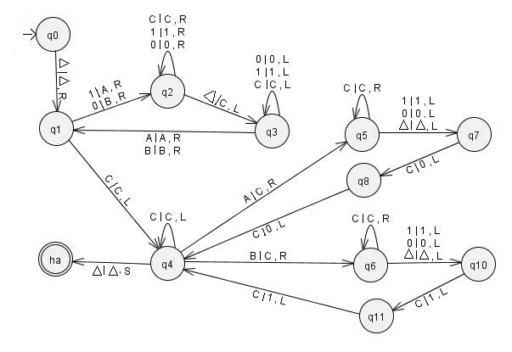

**Output on given string:**You have to run the TM on the string 101101 (make sure input is enclosed between ∆’s on TM).After processing what is the output of tape?

|  |  |  |  |  |  |  |  |  |  |  |  |  |  |  |  |  |  |  |  |  |  |  |  |  |  |  |  |  |  |  |  |  |  |  |  |  |  |  |  |  |  |  |  |  |  |  |  |  |  |  |  |  |  |  |  |  |  |  |  |  |  |  |  |  |  |  |  |  |  |  |  |  |  |  |  |  |  |  |  |  |  |  |  |  |  |  |  |  |  |  |  |  |  |  |
| --- | --- | --- | --- | --- | --- | --- | --- | --- | --- | --- | --- | --- | --- | --- | --- | --- | --- | --- | --- | --- | --- | --- | --- | --- | --- | --- | --- | --- | --- | --- | --- | --- | --- | --- | --- | --- | --- | --- | --- | --- | --- | --- | --- | --- | --- | --- | --- | --- | --- | --- | --- | --- | --- | --- | --- | --- | --- | --- | --- | --- | --- | --- | --- | --- | --- | --- | --- | --- | --- | --- | --- | --- | --- | --- | --- | --- | --- | --- | --- | --- | --- | --- | --- | --- | --- | --- | --- | --- | --- | --- | --- | --- | --- | --- |
| |  |  |  |  |  |  |  |  |  |  |  |  |  |  |  |  |  |  |  |  |  |  |  |  |  |  |  |  |  |  |  | | --- | --- | --- | --- | --- | --- | --- | --- | --- | --- | --- | --- | --- | --- | --- | --- | --- | --- | --- | --- | --- | --- | --- | --- | --- | --- | --- | --- | --- | --- | --- | | Tape you are given: | | | | | | | |  |  | |  | |  | |  | |  | | |  |  |  |  |  |  |  |  |  |  | | --- | --- | --- | --- | --- | --- | --- | --- | --- | --- | | **∆** | **1** | **0** | **1** | **1** | **0** | **1** | **∆** | **∆** | **∆** | | | |  | | | | | | | |  |  | |  | |  | |  | |  | |  | | | Output Tape: | | | | | | | |  |  | |  | |  | |  | |  | |  | | | **∆** | **0** | **0** | **1** | **1** | **0** | **0** | **0** | **0** | | **1** | | **1** | | **0** | | **0** | | **∆** | | |  |
|  |  |
|  |  |

**Description of TM:** Tell in words what it is doing (answer should be generic).

**Problem 6: MultiTape Turing Machine [15 points]**

The 3 tape Turing Machine **Equal** operates as follows:

TM halts in ***halt state*** with ***stationary head*** if it accepts the following language.

